

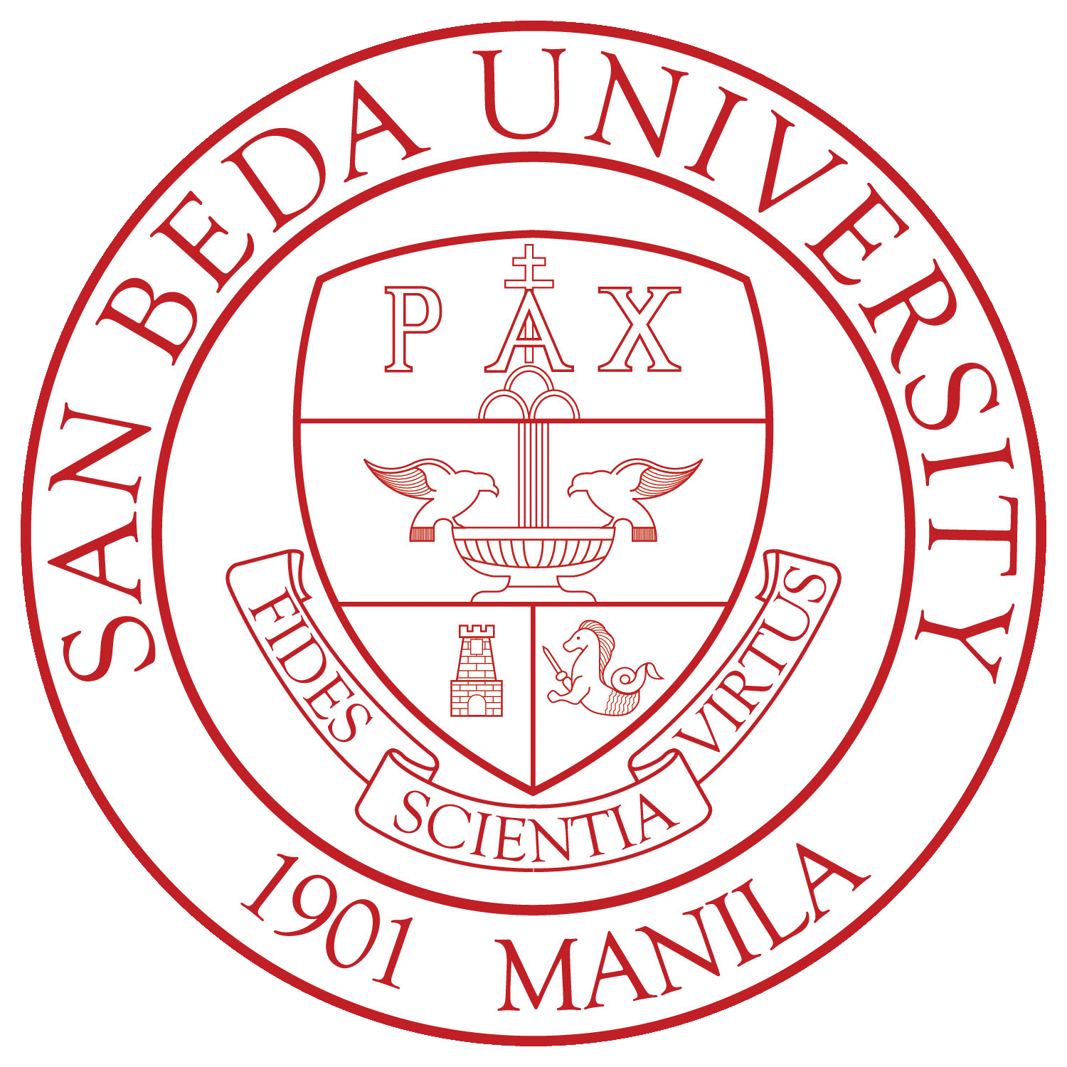

NAME OF ORGANIZATION

**Memorandum of Agreement**

SAN BEDA UNIVERSITY

COLLEGE OF ARTS AND SCIENCES

**OFFICE OF THE PREFECT OF STUDENT ACTIVITIES**

[opsa@sanbeda.edu.ph](mailto:opsa@sanbeda.edu.ph)

This is to certify that (**Company Name)** has agreed to become the **Official partner** of the (**Name of the Organization) of San Beda College** for the **(Event)** to be held on **(Date/s),** giving the assurance of that **(Company Name)** will be part of this event/activity conducted by the **(Name of the Organization) of San Beda College**

**(Company Name)** has agreed to give the **(Organization Name)** the following:

* ______________________
* ______________________

In return, the **(Organization Name)** will provide **(Company Name)** with the following benefits:

* _____________________
* _____________________

Prepared by:

*CONFORME:* ***Company Name***

***NAME:***

***POSITION:***

**EVP NAME**

*External Vice President*

*(Organization)*

Witnessed by:

**MARIAH LEVINIA L. MITRA**

*External Vice President*

*San Beda College Student Council – College of Arts and Sciences*

Approved by:

**DR. MARVIN R. REYES**

*Prefect of Student Affairs – College of Arts and Sciences*